Order Of Service

Singing: Psalm 119b—CW page 110

Reading: Psalm 68:1-18

Opening Hymn: TLH 30

Reading: Ephesians 6:10-24

Request Hymn: CW Supplement 716

Reading: Mark 12:35-40

Sermon Hymn: TLH 140

Sermon Text: Luke 22:39-46

About A Stone’s Cast

Prayer

The Apostles’ Creed, TLH page 12

Holy Communion

The Lord's Prayer

The Blessing

Closing Hymn: TLH 47

************

Bible Study: Lambs: The Sun
Sheep: Deuteronomy 4:41-49
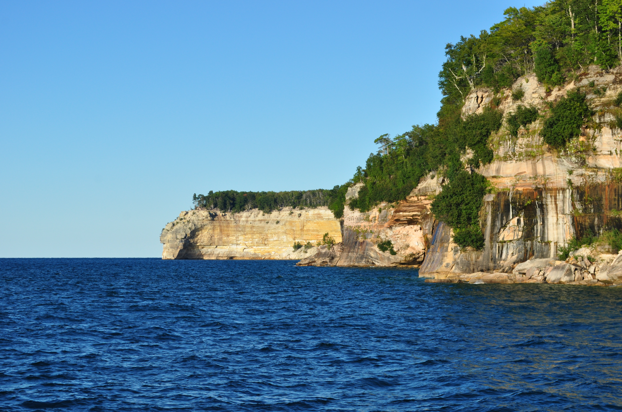

Summer In Michigan

Water
Of
Life

16 July 2023

W A T E R O F L I F E

Independent Christian Church—Conservative Lutheran Doctrine

Worship Service: 9:30 a.m.

Larry Cooper, Pastor E-Mail address:
lcooper@wateroflife.cc
Web Site:
www.wateroflife.cc

* * * * * * * * * * * * * * * * * * * * * * * * * * *

Sermon Text: Luke 22:39-46

About A Stone’s Cast

* * * * * * * * * * * * * * * * * * * * * * * * * * *

39 And he came out, and went, as he was wont, to the mount of Olives; and his disciples also followed him.
40 And when he was at the place, he said unto them, Pray that ye enter not into temptation.
41 And he was withdrawn from them about a stone's cast, and kneeled down, and prayed,
42 Saying, Father, if thou be willing, remove this cup from me: nevertheless not my will, but thine, be done.
43 And there appeared an angel unto him from heaven, strengthening him.
44 And being in an agony he prayed more earnestly: and his sweat was as it were great drops of blood falling down to the ground.
45 And when he rose up from prayer, and was come to his disciples, he found them sleeping for sorrow,
46 And said unto them, Why sleep ye? rise and pray, lest ye enter into temptation.

